Cherrydale Citizens Association Meeting Minutes
March 20, 2013

Members/Neighbors in Attendance:
12 CCA members / other interested people

CCA Officers in Attendance:
Maureen Ross, President
Andy Claster, Vice President
Meg Miller Rydzewski, Secretary

And from the NC Survey Committee:
Debby Cook and Gillian Burgess

CCA President Maureen Ross opened the meeting and welcomed all in attendance.

She introduced the main topic of the evening: The Neighborhood Conservation Survey

The 2013 NC Survey: Maureen Ross

Our last survey in 2004 included 88 open-ended questions. One major thing we learned from that was that we should never do 88 open-ended questions.

This time, the survey will be conducted online. If you cannot complete the survey online at home, at work, or at the library, we can get you a hard copy. Respondents have one month to complete the survey, then the NC Committee will compile the NC Plan. This guides the County on what our next conservation projects are.

Because of the last survey, we quickly had 4 projects in a row listed in priority and we rounded up people to quickly take care of them. The survey also guides our development in terms of major construction, both residential and commercial. We are also due to do a Lee Hwy development plan. Our 2013 NC Survey has a whole section on Lee Hwy that will really guide how we see the rest of Lee Hwy. We’ll get a lot of points for these projects, maybe $1 million toward them. The next one, Oak Grove, might take 2-3 years.

We’re going to do some dreaming here to see what we see shaping up in Cherrydale. We took a lot of NC survey questions from 1994 and from the original in 1984, so we’ve got consistency, but also have a lot of new questions. We formed a committee which made the survey stronger and more creative.. We beta tested the survey with a mom, a retired person, a person who’s already raised a family, a single person. We’ve recruited lots of perspectives.

We already voted in the bonds for NC, so it’s bond money that should be protected Our work should not be wasted. Express your opinion by filling out the survey.

Maureen then led the group in a brainstorming exercise. She asked that we write down what we really value and want in Cherrydale in the next 10-20 years. What we’d like to preserve. We pasted these on sticky notes and organized them on the wall, then discussed them.

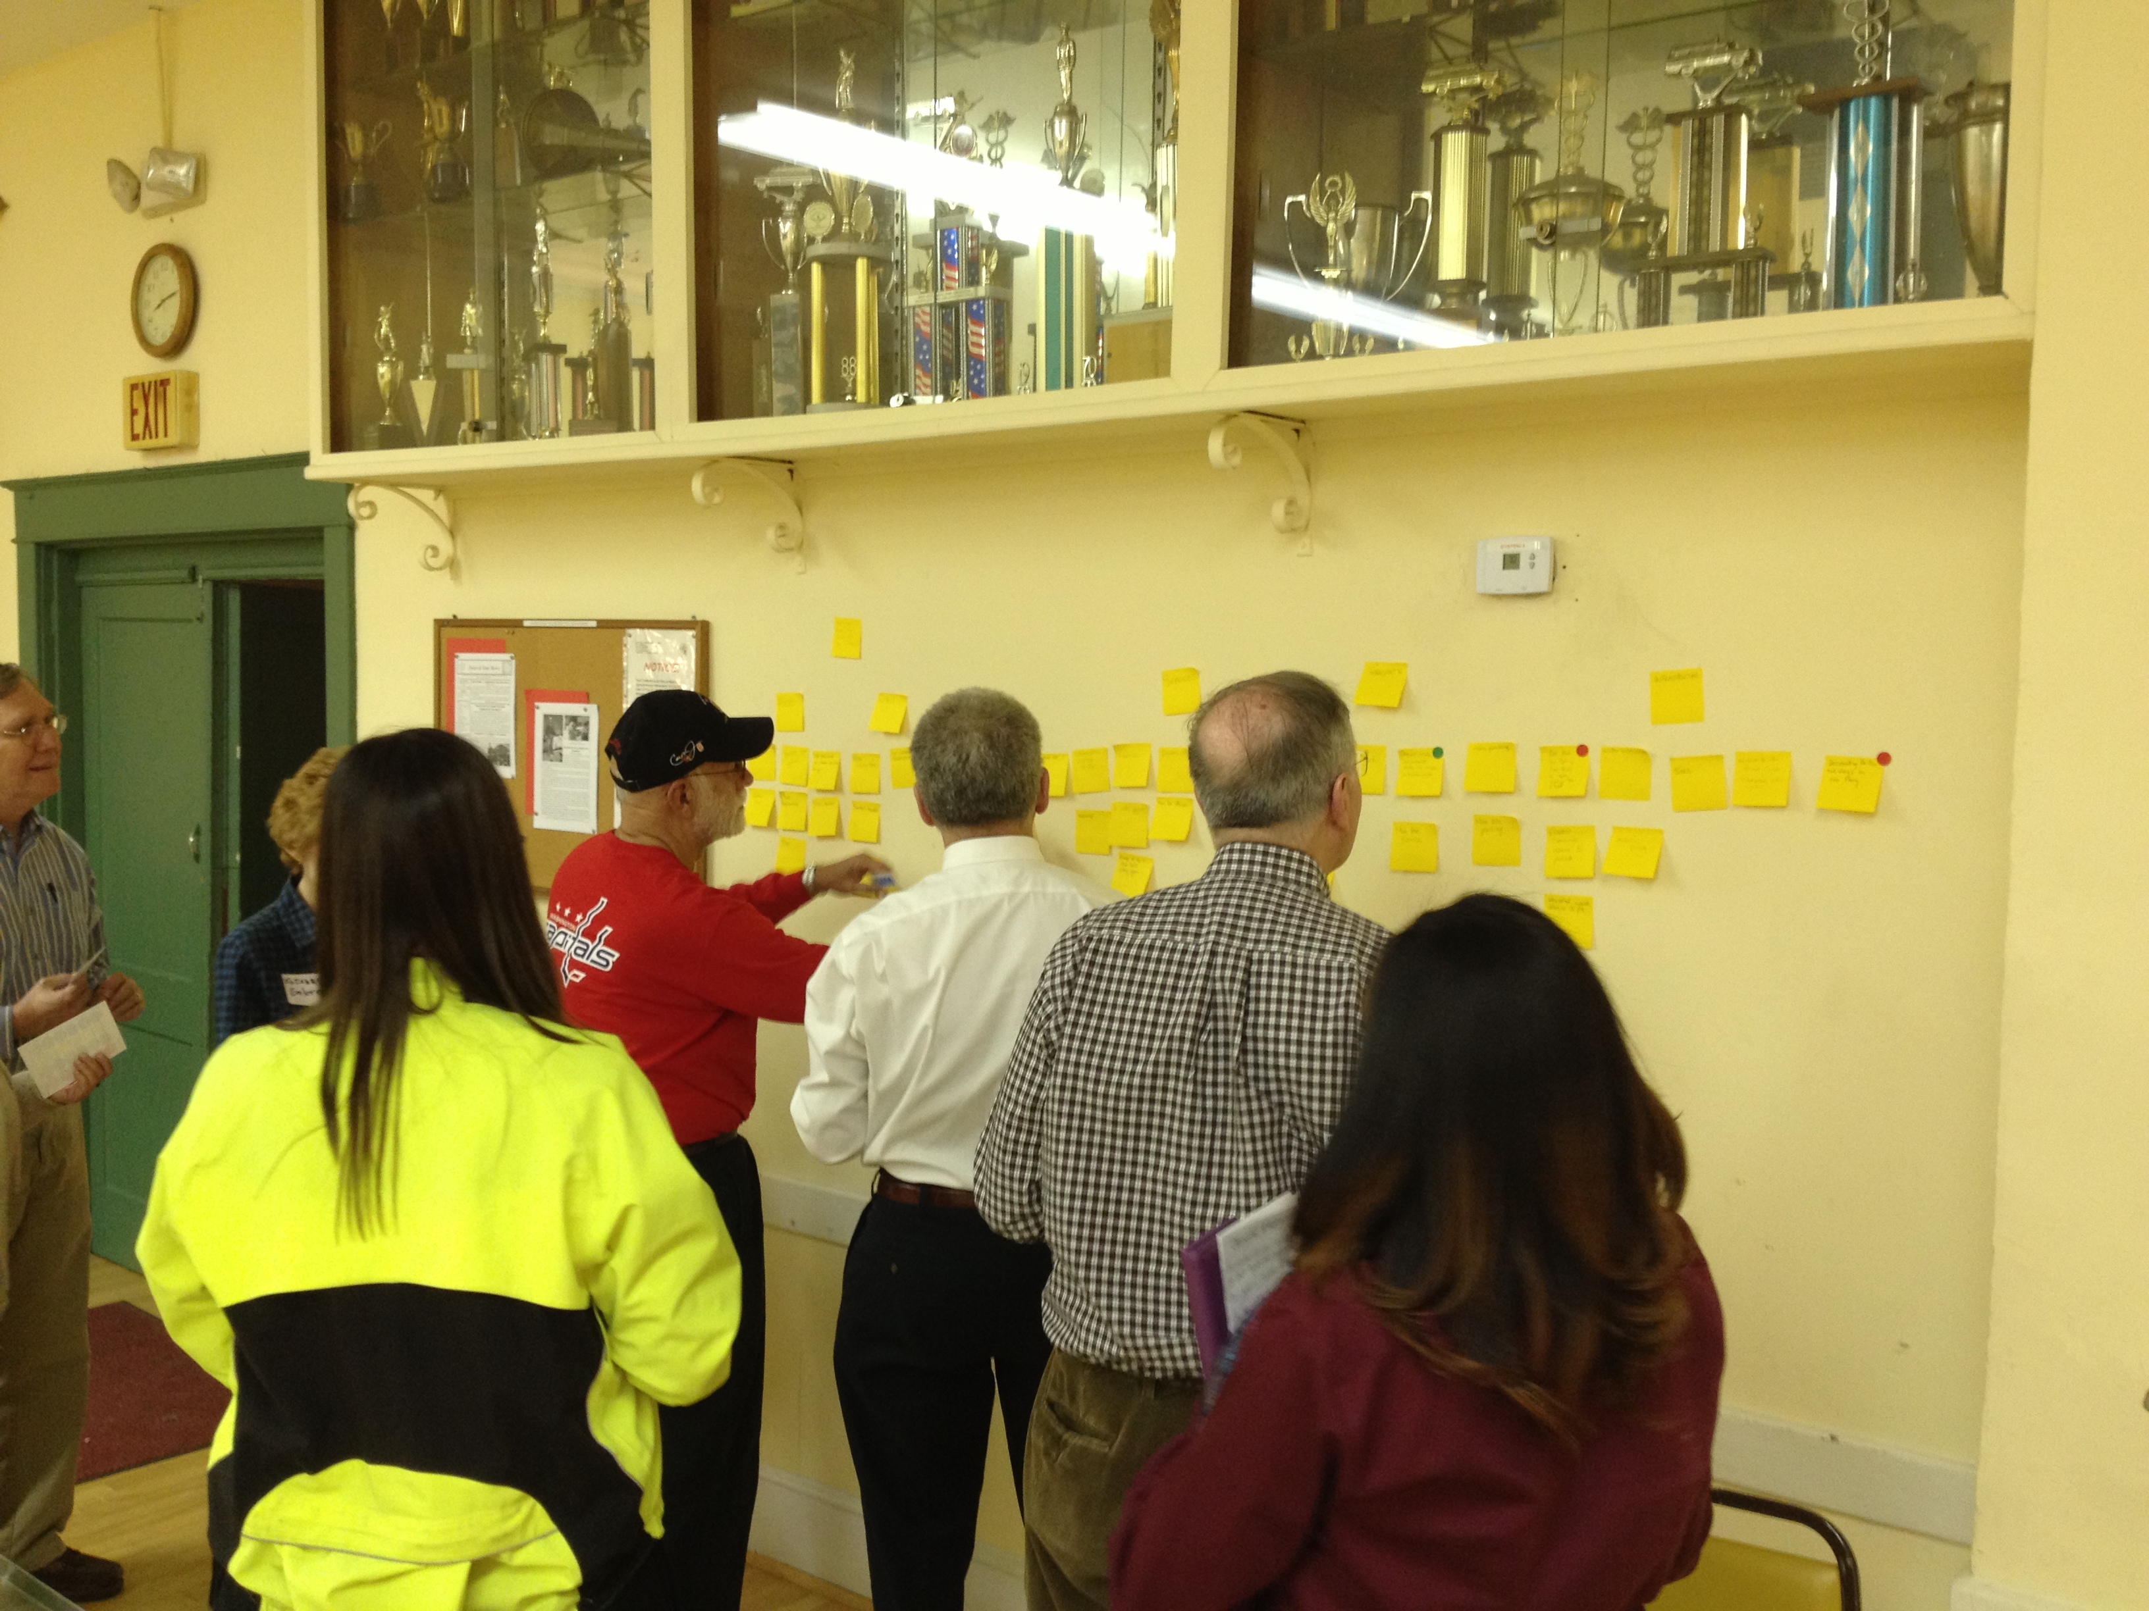

When all was done, here’s what was produced, in order of cumulative priority:

- 4 votes for sidewalks (to retail, too)
- 4 votes for family-friendly
- 3 votes for Library
- votes for retail (1 vote for restaurants, 3 votes for Safeway, 2 votes for Cherrydale Hardware)
- 2 votes limit on the size of buildings to 4 stories
- 2 votes for the volunteer fire station
- 1 vote for preserve the history
- 1 vote for single family homes
- 1 vote for historic homes
- 1 vote for variety of styles and size of homes
- 1 vote for community events (parade, parties, Santa at firehouse, a proposed annual evening of one-act plays)
- 1 vote for parks (open spaces, preserve the parks)
- 1 vote for good communication (the listserv, website and Sweet & Sour News)
- 1 vote for bike trails
- 1 vote for St Agnes Church, school
- 1 vote for maintain bus service
- 1 vote for safe residential streets

Maureen then asked us what we want on Lee Hwy Commercial IN FUTURE THAT WE DON’T ALREADY HAVE. Maureen asked us to write our ideas on stickies, put them on the wall, then put colored stickers on our priorities (red 4 pts, green 3 pts, yellow 2 pts, blue 1 pt).

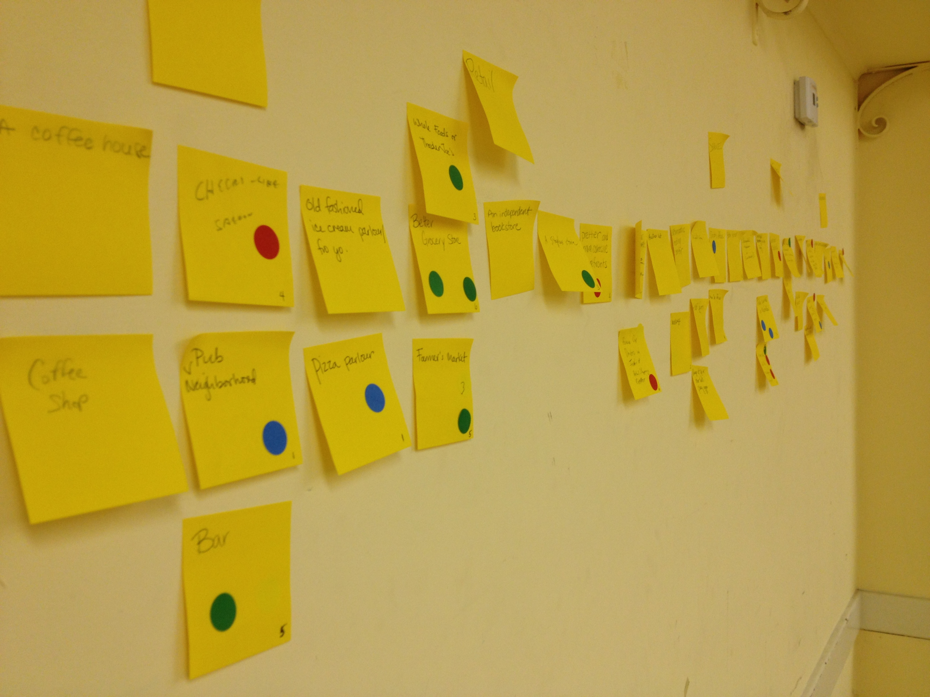

When all was done, here’s what was produced, in order of cumulative priority:

- Metro station without accompanying development = 11 pts
- Elevated crosswalk at the 5 points intersection / better crossing safety on Lee Hwy = 9 pts
- Better grocery 6 pts + Whole Foods = 9 pts
- Bar = 9 pts
- Remove car dealerships = 6 pts
- More doctor offices = 5 pts
- More buses = 5 pts
- Farmer’s Market = 5 pts
- Prettier and more cohesive storefronts = 4 pts
- Staples store = 3 pts
- Trolley = 2 pts
- Massage = 2 pts
- Pizza parlor = 1 pt
- More parking = 1 pt

A final vote was made in the form of daffodils (appropriate given it was the first day of spring).
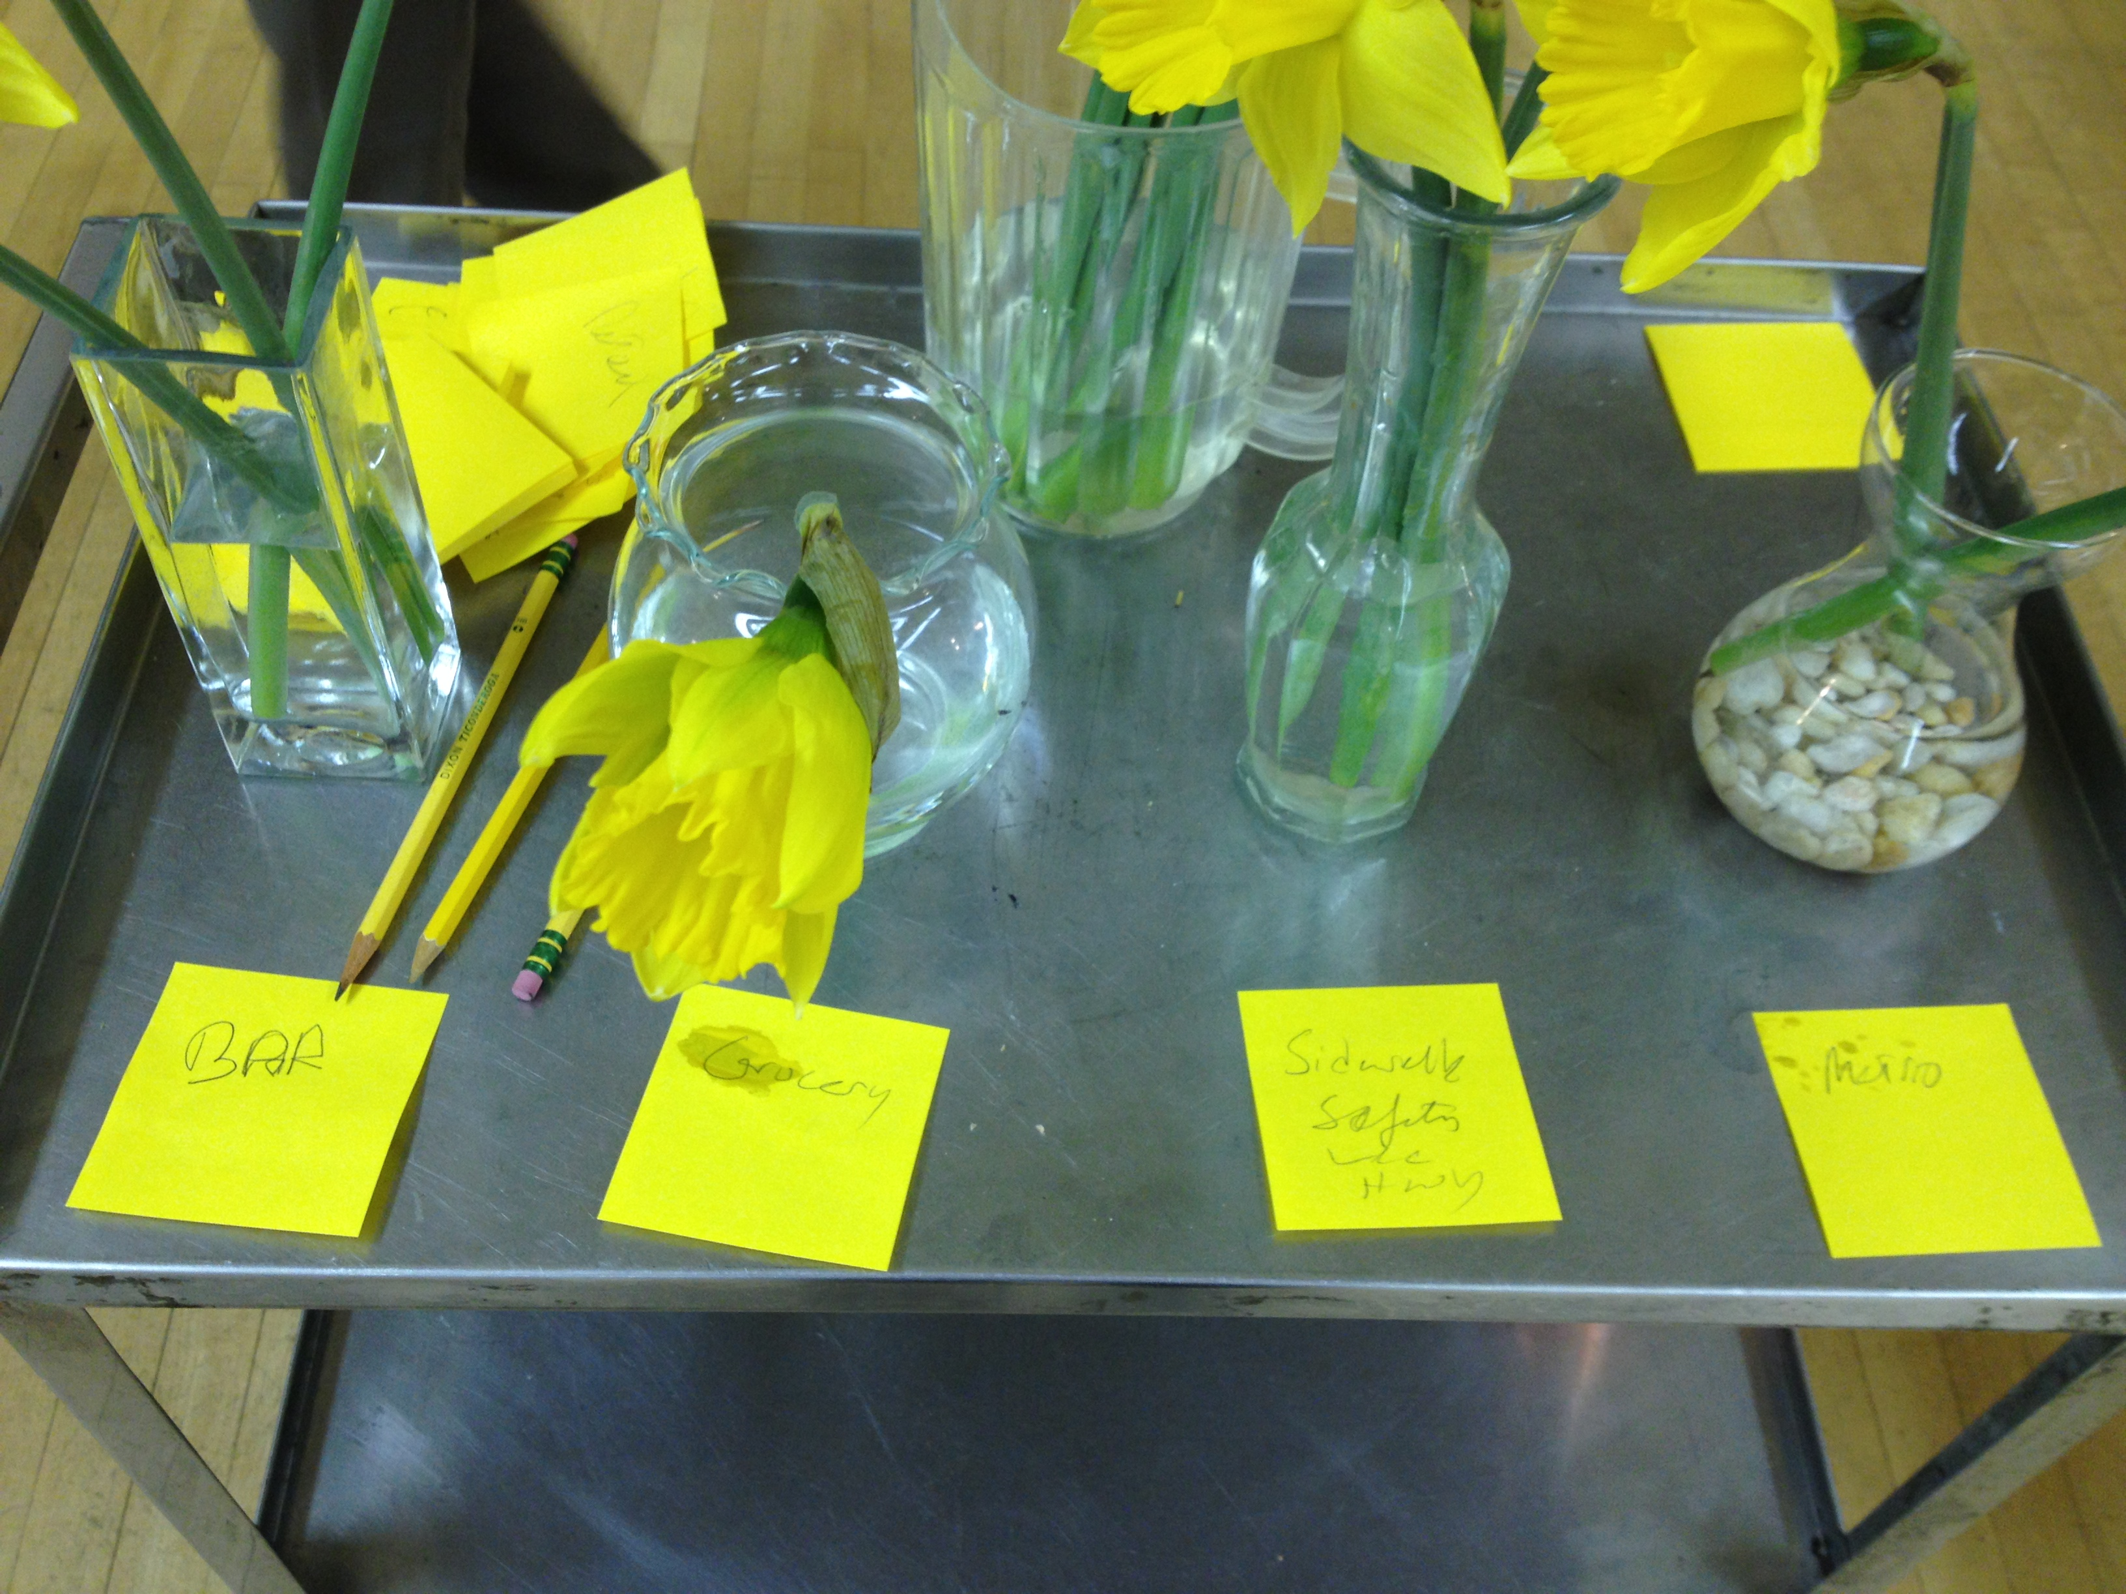

The result: the group gathered at the CCA Meeting would most like to see a neighborhood bar and better sidewalk safety/street crossing on Lee Hwy.

This kind of participation, creativity, and brainstorming is fun, but It’s also how we as a community can get things done that are important to us.

Maureen requested that we all get the word out about the NC Survey. We are doing a leafleting, but we also ask for everyone to get the word out on their own, too.

THIS IS IMPORTANT. IT’S OUR ONCE-EVERY-10-YEARS OPPORTUNITY.

Multimodal Transportation and Student Safety Special Committee: Gillian Burgess

Gillian Burgess is on the Multimodal Transportation and Student Safety Special Committee.

Transportation to school in the morning is 40%-ish of traffic. If you have any concerns or questions about it, please contact her. She lives in the modern house on N 20th St near N. Pollard. Knock on her door or shoot her an email and let her know of your interest. Gillian.Burgess@gmail.com.

Interesting fact of the evening:

The oldest commercial building in Cherrydale is the building that houses the Rod and Reel shop.

